C. elegans Synchronizer System
CES-5000
Protocol for synchronization of L1 nematodes

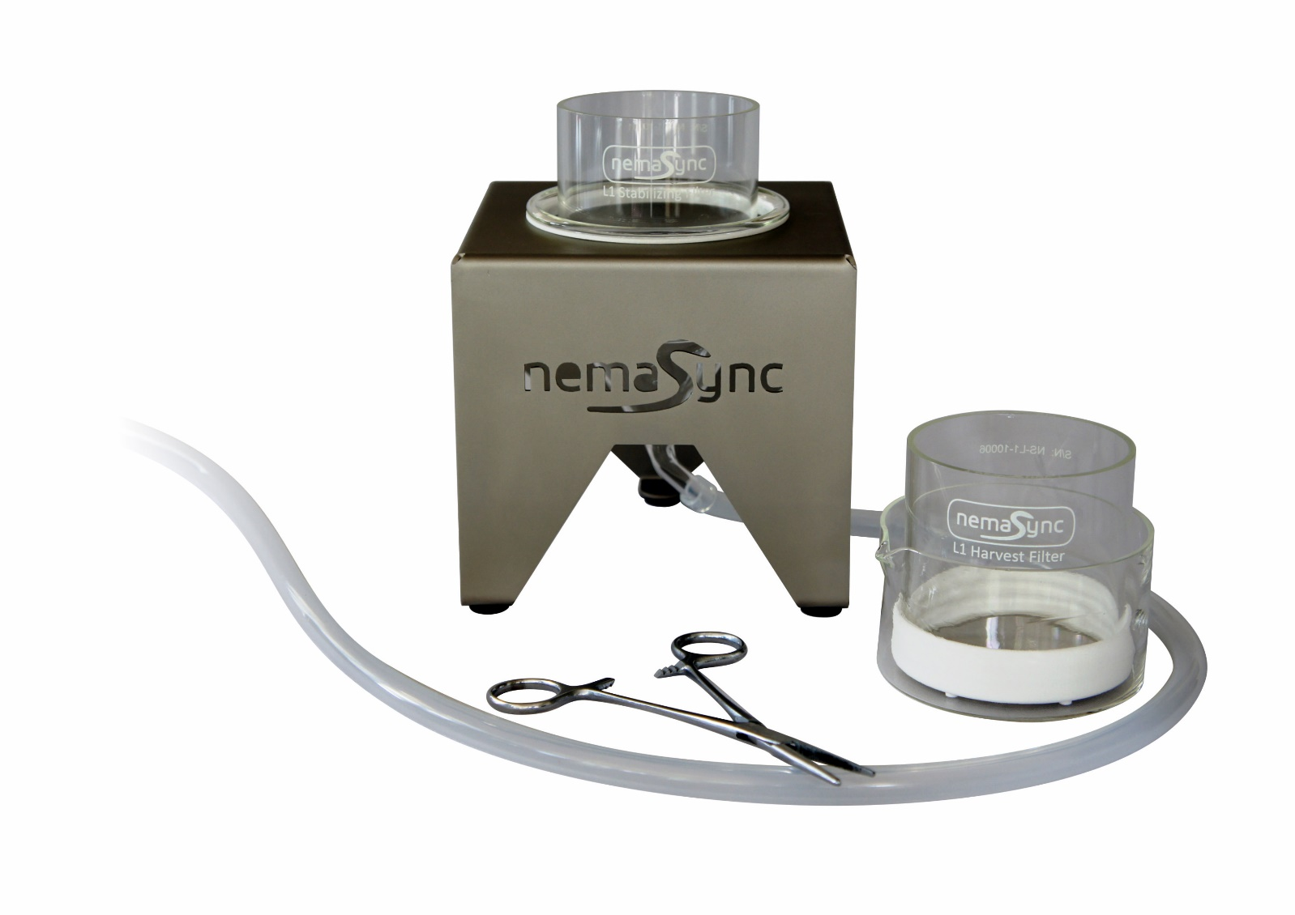
Warning:
- Make sure to protect the filters when not in use by placing a 90mm petri dish cap on each side.
- When working with pipettes, be careful not to puncture the filters.
- Before use, please read the general instructions.
Preparation:
- Sterilize the filters, funnel, crystallizing dish, etc, with 70% ethanol and rinse once with sterile, demi water or M9/S-media.
- For optimal yield and synchronization the majority of the C. elegans culture should consists of gravid adults and eggs.
Protocol:
A: Stabilizing of Gravid Population
- Place funnel in holder.
- Attach tubing to funnel and place end of tubing in a (waste) container / receiver.
- Place the “Stabilization filter” in the funnel.
- Select a population of worms (from NGM plate or liquid culture) with a high number of gravid adults. Ensure the population is well fed for optimal L1 yield.
- Transfer the worms to “Stabilization Filter” with glass pipet.
- Rinse the worms in the stabilization filter with sterile M9/S-media till most debris is removed.
- Close/pinch the silicone waste tube using a Hemostat clamp or similar device.
- Fill the stabilization filter and funnel with M9/S-media a few (~5mm) millimeters above the filter surface.
- Let the worms sediment for 5 up to 10 minutes.
- Keep the Hemostat clamp closed and continue with Harvest steps below:
B1: Harvest L1’s in liquid
- Add ~10ml M9/S-media into a clean glass dish.
- Slightly tilt and place the “Harvest filter” in the dish with clean buffer. Make sure there is no air trapped under the filter! Make sure there is a few millimeters of M9/S-media above the filter surface.
- Transfer the content of the “Stabilizing filter” in to the “Harvest filter” with a glass pipet. Make sure the entire bottom and top of the filter is covered with buffer in order to let the L1 nematodes through.
- Cover the top of the “Harvest filter” with a petri dish to prevent contamination and evaporation.
- Leave the “Harvest filter” in the dish for 15 minutes up to 12 hours / overnight*, depending on the amount and level of synchronization required. L1’s will hatch and pass through the filter.
- Slowly remove “Harvest filter” and set aside. At this point, the “Harvest filter’ could again be placed in a clean glass dish with buffer for a second harvest.
- Transfer contents of dish to conical tube(s).
- Use centrifuge to spin down L1’s (~5 minutes at 1200-2000g)
- Transfer worm pellet to seeded NGM plate or liquid culture.
* If large volumes are needed and food arrest is to be avoided; after approximately 7-8 hours (the time for newly laid egg’s to start hatching), the L1’s harvested till that point are to be disposed and a new short (1 – 2 hours) harvest cycle to be (re)started. See also remark about adding Serotonin at the Harvest step (11) of the protocol.
Cleaning / descaling the filters:
- Soak filters in a 0.5-1 M NaOH for 30 minutes up to 1 hour.
- Soak / rinse filters in distilled water.
  - Caution: do not use standard tap water as this typically contains dissolved salts and metals, as this will react to the nickel alloy and cause scaling.
- Cover the filters with a petri dish lid to avoid damaging the mesh.
- Optionally let the filters dry in a laminar flow hood.
If there is ‘scaling’ NEVER use an acid solution as it will have the potential of damaging the filters. Instead, use a small 40khz ultrasonic cleaning device with a ‘general purpose’ cleaning solution that has pH of 7 or higher. If not sure just use demi-water with a drop of general-purpose detergent and gently move / tilting the filter for 1 to 2 minutes in the ultrasonic cleaning device. To verify the result check the filter before and after under a microscope
Protocol demo:
A short video demonstrating the protocol steps can be found at: https://www.nemasync.com/ces#ces-video

Protocol revisions, updates and remarks:
We are continuously working on the improvements of the protocol with input and suggestions from users of the system. As such, we encourage users to share with us any suggestion / improvements, as we want to share this with other users in the C. elegans community.
For those who are seeking very large L1 volumes, some even up to 1m or more, the following remark: it is known that M9 and (excessive) movement are inhibitory for egg-laying. Besides making sure the population of worms is well fed, adding serotonin and/or acetylcholine have been shown to increase the overall rate of egg-laying [Trent et al 1983; Weinshenker et al. 1995].

Latest version:
The latest protocols, documentation, demo video can be downloaded at https://www.nemasync.com/documentation

