C. elegans Synchronizer System
CES-700
Protocol for synchronization of L1 nematodes

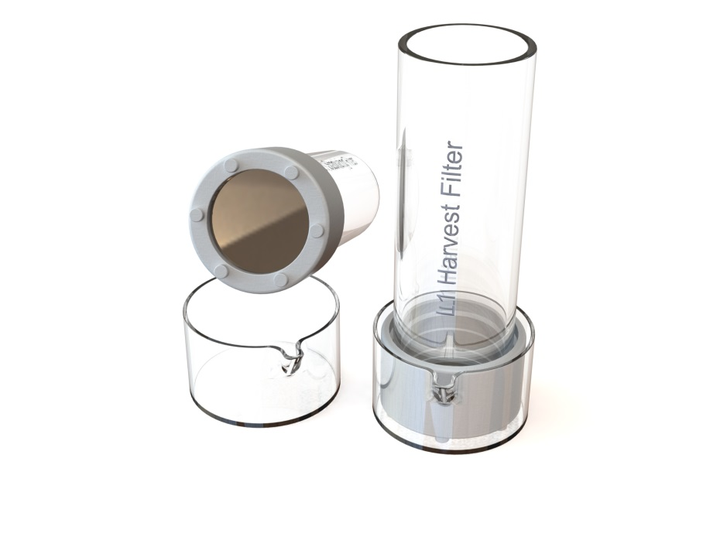
Warning:
- Make sure to protect the filters when not in use by placing a 90mm petri dish cap on each side.
- When working with pipettes, be careful not to puncture the filters.
- Before use, please read the general instructions.
Preparation:
- Sterilize the filters, funnel, crystallizing dish, etc, with 70% ethanol and rinse once with sterile, demi water or S Medium.
- For optimal yield and synchronization the majority of the C. elegans culture should consists of gravid adults and eggs.
Protocol:
A: Stabilizing of Gravid Population
- Place the “Stabilization filter” in a large (200mL or more) crystalizing dish.
- Select a population of worms (from NGM plate or liquid culture) with a high number of gravid adults. Ensure the population is well fed for optimal L1 yield.
- Transfer the worms to “Stabilization Filter” with glass pipet.
- Rinse the worms in the stabilization filter with sterile water or S Medium till most debris is removed.
- Add ~10ml S Medium into a clean ~20mL glass crystalizing dish. A 50mm crystalizing dish as supplied can be used.
- Slightly tilt the dish and filter and slowly place the “Stabilization filter” in the dish with S Medium. Make sure there is no air trapped under the filter! There should be a few millimeters of S Medium above the filter surface.
- Let the worms sediment for 5 up to 10 minutes.
B: Harvest L1’s
- Add ~10ml S Medium into a clean ~20mL glass crystalizing dish. A 50mm crystalizing dish as supplied can be used.
- Slightly tilt the dish and filter and slowly place the still empty “Harvest filter” in the dish with clean buffer. Make sure there is no air trapped under the filter! There should be a few millimeters of S Medium above the filter surface.
- Transfer the content of the “Stabilizing filter” in to the “Harvest filter” with a glass pipet. Make sure the entire bottom and top of the filter is covered with buffer in order to let the L1 nematodes through.
- Optionally cover the top of the “Harvest filter in order to prevent contamination and evaporation.
- Leave the “Harvest filter” in the dish for 15 minutes up to 12 hours / overnight*, depending on the amount and level of synchronization required. L1’s will hatch and pass through the filter.
- Slowly remove “Harvest filter” and set aside. At this point, the “Harvest filter’ could again be placed in a clean glass dish with buffer for a second harvest.
- Transfer contents of dish to conical tube(s).
- Use centrifuge to spin down L1’s (~5 minutes at 1200-2000g)
- Transfer worm pellet to seeded NGM plate or liquid culture.
* If large volumes are needed and food arrest is to be avoided; after approximately 7-8 hours (the time for newly laid egg’s to start hatching), the L1’s harvested till that point are to be disposed and a new short (1 – 2 hours) harvest cycle to be (re)started. See also remark about adding Serotonin at the Harvest step (8) of the protocol and not using M9 as this inhibits egg-laying.

Cleaning / descaling the filters:
1a Soak filters in a 0.5-1 M NaOH for 30 minutes up to an 1 hour.
1b Alternative: use a small 2 liter 40 Hz ultrasonic cleaner, filled with 0.5-1 M NaOH, and clean the filters for approximately 5 minutes. The ultrasonic cleaner will also help descale filters if this becomes necessary.
2 Soak / rinse filters in distilled water.
Caution: do not use standard tap water as this typically contains dissolved salts and metals, as this will react to the nickel alloy and cause scaling.
3 Sterilize the filters with 70% isopropyl alcohol, either use a spray or submerge the filters completely.
4 Let the filters dry in a laminar flow hood.
5 Cover the filters with a petri dish lid.
If there is ‘scaling’ NEVER use an acid solution as it will have the potential of damaging the filters. Instead, use a small 40khz ultrasonic cleaning device with a ‘general purpose’ cleaning solution that has pH of 7 or higher. If not sure just use demi-water with a drop of general-purpose detergent and gently move / tilting the filter for 1 to 2 minutes in the ultrasonic cleaning device. To verify the result check the filter before and after under a microscope
Guidelines when working with the CES:
In order to avoid contamination, always try to work in a laminar flow hood if possible

Contamination: (Cleaning Buffer)
The source (plates or liquid) can be a suspect of contamination. If this is the case, then the following Cleaning Buffers
could/should be used.
Cleaning buffer 50 mL: M9 + Streptomycin + Nystatin –solution :
1 Streptomycin stock 100 mg/mL
Add 1 gram of Strep to 10 mL of dH2O, filter sterilize the solution and store at 4˚C
2 Nystatin suspension 10 mg/mL
For 50 mL, add 0.5 gram Nystatin in 70% ethanol in dH2O (Shake before use) store at 4˚C
3 Prepare 50 mL of sterile M9 buffer
add 50 µL Streptomycin stock 100 mg/mL and 50 µL Nystatin suspension 10 mg/mL
4 Transfer the L1’s to a 50 mL tube and add 10 mL cleaning buffer, incubate for 5 minutes.

Large(r) L1 volumes:
For those who are seeking (very) large L1 volumes, the following remarks:
Egg-laying stimulus:
In the nematode C. elegans, serotonin has been shown to act in a modulatory fashion to increase the rate and alter the temporal pattern of egg laying and acts directly on the vulval muscles to increase the frequency of Ca2+ transients. [Trent et al 1983; Weinshenker et al. 1995].
Assay conditions as used in some experiments: 5-hydroxytryptamine (creatinine sulfate complex, Sigma) added to NGM agar at 7.5 mM. There are no concentration know for a liquid buffer, however we suggest using the same concentration, or slightly less 5 mM.
In the CES protocol, Serotonin should be added to the buffer as used in the last step of the protocol, the ‘Harvest’ step.
Egg-laying inhibitors:
Mechanical stimulation such as vibration of the culture medium inhibits egg-laying, (Sawin, 1996). Hypertonic salt solutions such as M9 salts also strongly inhibit egg-laying (Horvitz et al., 1982).

Protocol demo:
A short video demonstrating the protocol steps can be found at: https://www.nemasync.com/ces#ces-video

Protocol revisions, updates and remarks:
We are continuously working on the improvements of the protocol with input and suggestions from users of the system. As such, we encourage users to share with us any suggestion / improvements, as we want to share this with other users in the C. elegans community.

Latest version:
The latest protocols, documentation, demo video can be downloaded at https://www.nemasync.com/documentation

