Adult
Separation
Protocol
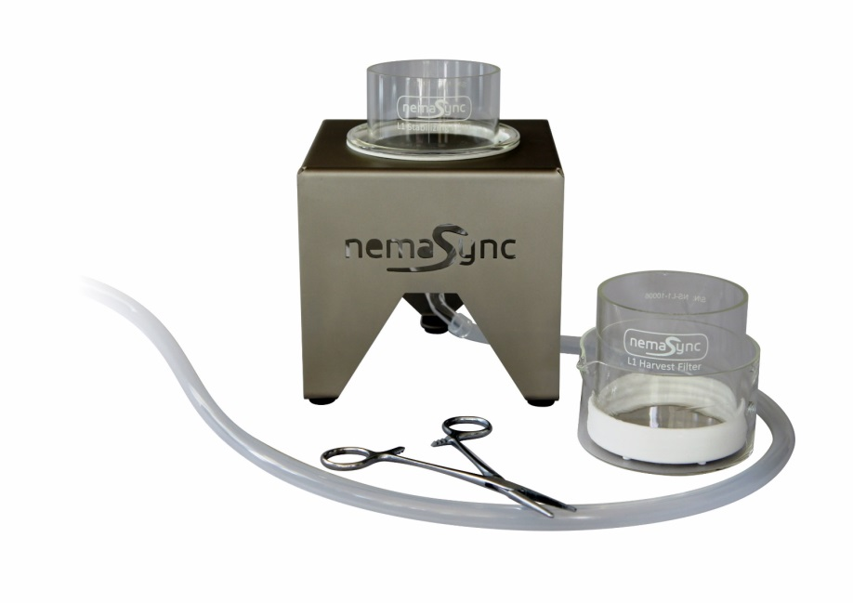
Using CES-700/5000

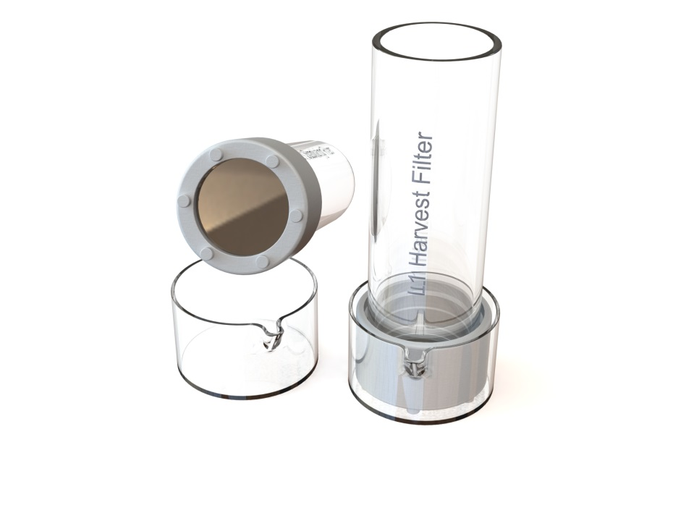

Warning:
- Make sure to protect the filters when not in use.
- When working with pipettes, be careful not to puncture the filters.
- Before use, please read the general instructions.
Preparation:
- Sterilize the filters, funnel, crystallizing dish, etc, with 70% ethanol and rinse once with sterile, demi water or M9/S-media.
This protocol is written to separate Adults from offspring *
CES-700 Protocol:
A: Separating Adults from offspring
- Place the “Stabilization filter” in a large (200mL or more) crystalizing dish.
- Transfer the worms to the “Stabilization Filter” with glass pipet.
- Rinse the worms in the stabilization filter with sterile M9/S-media in order to remove most debris, etc.
- Add ~10ml M9/ S-media into a clean ~20mL glass crystalizing dish. A 50mm crystalizing dish as supplied can be used.
- Slightly tilt the dish and filter and slowly place the “Stabilization filter” and its content in the dish with M9/ S-media. Make sure there is no air trapped under the filter! There should be a few millimeters of M9/S-media above the filter surface.
- Let the worms sediment for 5 up to 15 minutes (or even longer).
- Tilt the “Stabilization Filter” and carefully wash with for example a pipet and clean media the adults to one side of the filter surface.
- Pipet the adults from the filter and transfer to conical tube(s).
- Use centrifuge to spin down L1’s (~5 minutes at 1200-2000g)
- Transfer worm pellet to seeded NGM plate or liquid culture.
This procedure should be repeated within an interval of 24 up to 48 hours depending on temperature. The longer the interval and temperature the higher the chances are that young hatchlings/nematodes (L1, L2, etc) develop in to larger young adult and may no longer pass through the filter. The optimal (max) time-window still needs to be tested / validated.

* still under development and may need further optimization
CES-5000 Protocol:
A: Separating Adults from offspring
- Place funnel in holder.
- Attach tubing to funnel and place end of tubing in a (waste) container / receiver.
- Place the “Stabilization filter” in the funnel.
- Transfer the worms to “Stabilization Filter” with glass pipet.
- Rinse the worms in the stabilization filter with sterile M9/S-media till most debris is removed.
- Close/pinch the silicone waste tube using a Hemostat clamp or similar device.
- Fill the stabilization filter and funnel with M9/S-media a few (~5mm) millimeters above the filter surface.
- Let the worms sediment for 5 up to 15 minutes.
- Tilt the “Stabilization Filter” and carefully wash with a pipet and clean media the adults to one side of the filter surface.
- Pipet the adults from the filter and transfer to conical tube(s).
- Use centrifuge to spin down L1’s (~5 minutes at 1200-2000g)
- Transfer worm pellet to seeded NGM plate or liquid culture.
This procedure should be repeated within an interval of 24 up to 48 hours depending on temperature. The longer the interval and temperature the higher the chances are that young hatchlings/nematodes (L1, L2, etc) develop in to larger young adult and may no longer pass through the filter. The optimal (max) time-window still needs to be tested / validated.

Cleaning / descaling the filters:
- Soak filters in a 0.5-1 M NaOH for 30 minutes up to 1 hour.
- Soak / rinse filters in distilled water.
  - Caution: do not use standard tap water as this typically contains dissolved salts and metals, as this will react to the nickel alloy and cause scaling.
- Cover the filters with a petri dish lid to avoid damaging the mesh.
- Optionally let the filters dry in a laminar flow hood.
If there is ‘scaling’ NEVER use an acid solution as it will have the potential of damaging the filters. Instead, use a small 40khz ultrasonic cleaning device with a ‘general purpose’ cleaning solution that has pH of 7 or higher. If not sure just use demi-water with a drop of general-purpose detergent and gently move / tilting the filter for 1 to 2 minutes in the ultrasonic cleaning device. To verify the result check the filter before and after under a microscope
Protocol revisions, updates and remarks:
We are continuously working on the improvements of the protocol with input and suggestions from users of the system. As such, we encourage users to share with us any suggestion / improvements, as we want to share this with other users in the C. elegans community.
Latest version:
The latest protocols, documentation, demo video can be downloaded at https://www.nemasync.com/documentation

